Subject | Mathematics Form 4
Form | 4
Date | 15th May 2014
Time | 11.00am – 11.10am (10 minutes)
Topic | Chapter 3: Sets
Sub-Topic | 3.1:Sets notation  3.2:Venn diagram
General Objective | 1. Understand and use the concept of set  2. Discuss the relationship between sets and universal sets.
Specific Objectives | At the end of this lesson, students should be able to:  - Determine whether a given set is a subset of a specific set and use the symbol.  - List the subsets for a specific set.  - Illustrate the relationship between set, and universal set using Venn Diagram
Lesson Content | - To determine subset of a specific set.  - To illustrate the set using Venn diagram representation.
Reference | - Textbook: Mathematics Form 4.  - Kertas Peperiksaan Percubaan SBP 2007
Inculcation of Values | Be systematic, Rational, Proactive
Teaching Materials | Whiteboard, Marker, Textbook, Worksheet
Procedures | 1. Set Induction | 1.1 Teacher give a short brief explanation about sets
Procedures | 2. Lesson Development | 2.1 Teacher explains that students are going to learn universal sets  2.2 Students need to recall their previous knowledge about group of sets.  2.3 Students need to give opinion why they need to learn this topic and its use.  Notes:  Symbols in a set:  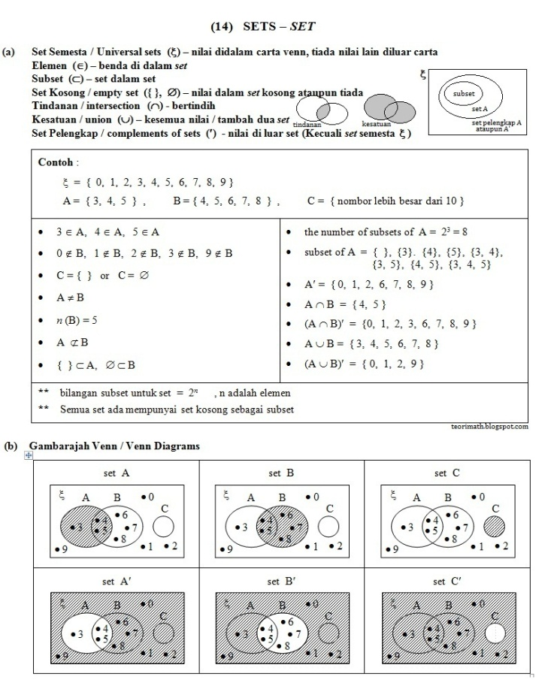  Examples:  The Venn Diagram in the answer space shows set K,L and M such that the universal set, ξ = K U L U M. On the diagrams in the answer space, shade:  a) L U M’  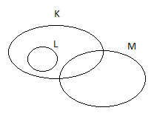  b) (K ∩ M), U L
Procedures | 3. Conclusion | 3.1 Teacher reviews today’s lesson with students verbally.
Procedures | 4. Evaluation | 4.1 Teacher gives some exercises to gauge student’s level of understanding.  4.2 Teacher asks students to do on the whiteboard.
Follow up Activities | Students are required to do some exercises taken from worksheet given and workbook as their homework.
Reflection | Students must know how to use their imagination in order to convert a set in the form of venn diagram. Schematic learning applied here.

