

TESTING AND ASSESSMENT
(EDP 3501K)

MINITEST PROJECT REPORT

NAME : NUR LIYANA BINTI MOHD KASIM (1113040)
NOOR ADIBAH BT MEOR AHMAD (1118852)
LECTURER : DR. JOHARRY B. OTHMAN
INTRODUCTION

This Minitest Project provides the knowledge and skills needed to design student assessment, test and exam questions. The project will also expose student with the process of test analysis. Besides that, through test analysis, student will learn more on how to improve the test and how to overcome issues and problems arise from the test.

Purposes of Test:
The purposes of this Minitest Project are to:
- learn how to construct a good multiple-choice question.
- plan and administer a classroom test.
- find out how to analyse the test based on three item analysis methods; item difficulty, item discrimination and distractor analysis.
- get the idea to apply Rasch analysis through the Winsteps software in order to obtain a detailed analysis of the test.
- point out issues or problems arise from this test.

DATA ANALYSIS
- Item Difficulty

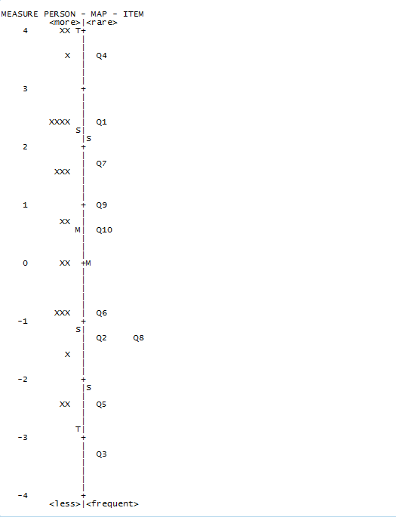
The picture above shows the questions ranking from higher order thinking to lower order thinking. It clearly shows that item number four is the most hardest question while item number three is the easiest question.
- Discrimination index and distractor analysis

Q1 :
Students | A | B | C* | D
Upper 25% | 0 | 0 | 0.6 | 0.4
Lower 25% | 0 | 0.6 | 0.4 | 0
All | 0.1 | 0.3 | 0.3 | 0.3
Item discrimination index : |  |  | 0.2
Item difficulty index: |  |  | 0.3
Distractor analysis: |  | >Option A is not woking at all since no one chose it
 |  | >Option B works quite well as 60% of less-prepared students chose it
 |  | >Option C not woking quite well as 40% of best-prepared students
 |  | chose it but none from less-prepared students
Q2 :
Students | A | B | C* | D
Upper 25% | 0 | 0 | 1 | 0
Lower 25% | 0.4 | 0 | 0.6 | 0
All | 0.15 | 0 | 0.8 | 0.05
Item discrimination index: |  |  | 0.4
Item difficulty index: |  |  | 0.4
Distractor analysis: |  | >Option B and D are not woking at all since no one chose them
 |  | >Option A works quite well as 40% of less-prepared students chose it
Q3 :
Students | A | B* | C | D
Upper 25% | 0 | 1 | 0 | 0
Lower 25% | 0.2 | 0.8 | 0 | 0
All | 0.05 | 0.95 | 0 | 0
Item discrimination index: |  |  | 0.2
Item difficulty index: |  |  | 0.95
Distractor analysis: |  | >Option C and D are not woking at all since no one chose them
 |  | >Option A works quite well as 20% of less-prepared students chose it

Q4 :
Students | A | B* | C | D
Upper 25% | 0 | 0.8 | 0 | 0.2
Lower 25% | 0.4 | 0 | 0 | 0.6
All | 0.35 | 0.2 | 0.05 | 0.4
Item discrimination index: |  |  | 0.8
Item difficulty index: |  |  | 0.2
Distractor analysis: |  | >Option C is not woking at all since no one chose it
 |  | >Option D is working well as 20% of best-prepared students and 60% of
 |  | less-prepared students chose it
 |  | >Option A works quite well as 40% of less-prepared students chose it
Q5 :
Students | A* | B | C | D
Upper 25% | 1 | 0 | 0 | 0
Lower 25% | 0.6 | 0.4 | 0 | 0
All | 0.9 | 0.1 | 0 | 0
Item discrimination index: |  |  | 0.4
Item difficulty index: |  |  | 0.9
Distractor analysis: |  | >Option C and D are not woking at all since no one chose them
 |  | >Option B works quite well as 40% of less-prepared students chose it
Q6 :
Students | A | B* | C | D
Upper 25% | 0 | 1 | 0 | 0
Lower 25% | 0.2 | 0.2 | 0.4 | 0.2
All | 0.05 | 0.75 | 0.15 | 0.05
Item discrimination index : |  |  | 0.8
Item difficulty index : |  |  | 0.75
Distractor analysis: |  | >Option C is working well as 40% of less-prepared students chose it
 |  | >Option A and D work quite well as both have 20% of less-prepared
 |  | students to choose them

Q7 :
Students | A* | B | C | D
Upper 25% | 1 | 0 | 0 | 0
Lower 25% | 0 | 0.2 | 0.6 | 0.2
All | 0.4 | 0.05 | 0.35 | 0.2
Item discrimination index: |  |  | 1
Item difficulty index: |  |  | 0.4
Distractor analysis: |  | >Option C is working well as 60% of less-prepared students chose it
 |  | >Option B and D work quite well as both have 20% of less-prepared
 |  | students to choose them
Q8 :
Students | A* | B | C | D
Upper 25% | 0.8 | 0.2 | 0 | 0
Lower 25% | 0.4 | 0.6 | 0 | 0
All | 0.8 | 0.2 | 0 | 0
Item discrimination index: |  |  | 0.4
Item difficulty index: |  |  | 0.8
Distractor analysis: |  | >Option C and D are not woking at all since no one chose them
 |  | >Option B is working well as 20% of best-prepared students and 60% of
 |  | less-prepared students chose it
Q9 :
Students | A | B | C | D*
Upper 25% | 0 | 0 | 0 | 1
Lower 25% | 0.2 | 0.6 | 0.2 | 0
All | 0.1 | 0.25 | 0.15 | 0.5
Item discrimination index: |  |  | 1
Item difficulty index: |  |  | 0.5
Distractor analysis: |  | >Option B is working well as 60% of less-prepared students chose it
 |  | >Option A and C work quite well as both have 20% of less-prepared
 |  | students to choose them

Q10 :
Students | A | B* | C | D
Upper 25% | 0 | 0.8 | 0 | 0.2
Lower 25% | 0.2 | 0 | 0.6 | 0.2
All | 0.1 | 0.55 | 0.2 | 0.15
Item discrimination index: |  |  | 0.8
Item difficulty index: |  |  | 0.55
Distractor analysis: |  | >Option D is working well as 20% of best-prepared students and 20% of
 |  | less-prepared students chose it
 |  | >Option C works well too as 60% of less-prepared students chose it
 |  | >Option A works quite well as 20% of less-prepared students chose it.

- Item Misfit Order

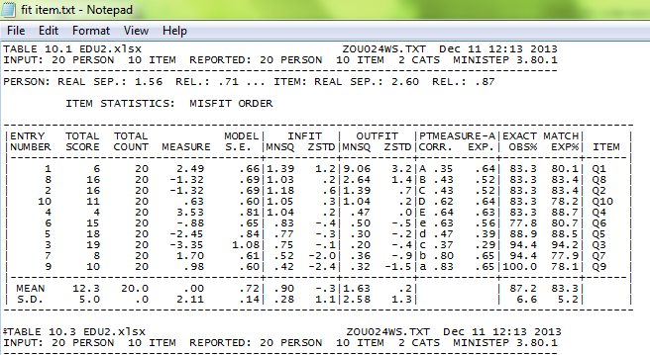
Based on the table, the infit mean for MNSQ of the item misfit order is 0.98. Four of the item; Q3, Q10, Q9, Q7, each have a MNSQ that is >1. On the other hand, two of the item; Q4, Q6, are all have a MNSQ that is >0.5 while only item Q8 and Q5 have a MNSQ that is <0.5.
Based on the table, the outfit mean for MNSQ of the item misfit order is 0.54. Item Q7 has the largest MNSQ with 1.08. Four of the item; Q3, Q10, Q9, Q4, each have a MNSQ that is >0.5. On the other hand, the other items; Q6, Q8, Q5, each have a MNSQ that is <0.5.
As a conclusion, the item that was prepared is not very good as it has a small MNSQ.

- Person Misfit Order
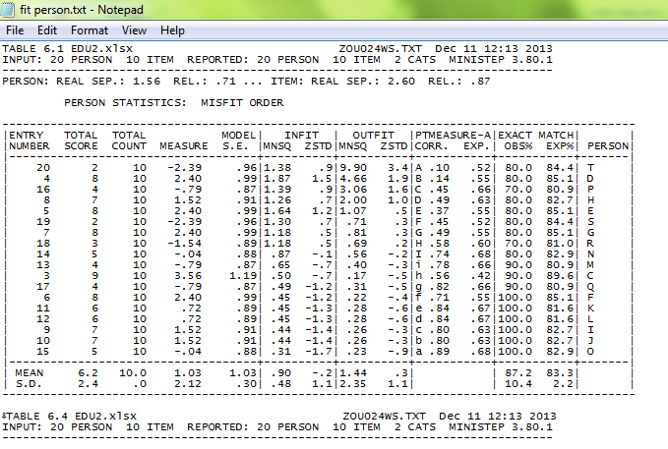
Based on the table, the infit mean for MNSQ of the person misfit order is 0.95. Six of the person; I, L, D, F, R, Q, each have a MNSQ that is >1. On the other hand, nine of the person; each have a MNSQ that is >0.5 while the other person each have a MNSQ that is <0.5.
Based on the table, the outfit mean for MNSQ of the person misfit order is 0.54. Person I and L have the largest MNSQ with 1.93. Three of the person; D, F, Q, each have a MNSQ that is >0.5 while the other persons each have a MNSQ that is <0.5.
As a conclusion, the person that took the exam is fairly good as it has a small MNSQ.
CONCLUSION

This Minitest Project has been conducted within 20 selected students. This test consists of ten multiple questions that consist four subtopic in Linear Algebra and varies in level of difficulties.
Based on this Minitest Project, ten questions were constructed and diagnosed into a few elements such as difficulty index, discrimination index and distractor analysis. Based on Rasch , it is found that the questions is high in terms of test reliability (0.77) and also high in term of person reliability (0.71). This means that the test is suitable for the 20 selected students.
From the Rasch analysis, it shows that all questions in this Minitest Project were constructed tally with specification tables that consists of how many items supposed to be for lower order thinking and higher order thinking.
Last but not least, we found that it is not easy to construct questions for the test. We would like to thank our honourable lecturer, Dr. Joe for guiding us in this course and we hope that in future we will be able to use whatever knowledge that we gain in this course.

